EXPERIMENT:9: Create a Snapshot of a VM and Test it by loading the Previous Version/Cloned VM.

STEP:1: GO TO THE VM AND GO TO THE SNAP SHOT AND CLICK THE SNAP SHOT 1 AND 2 WITH THE DETAILED DESCRIPTION OF THE DATE AND TIME AND THEN SAVE .

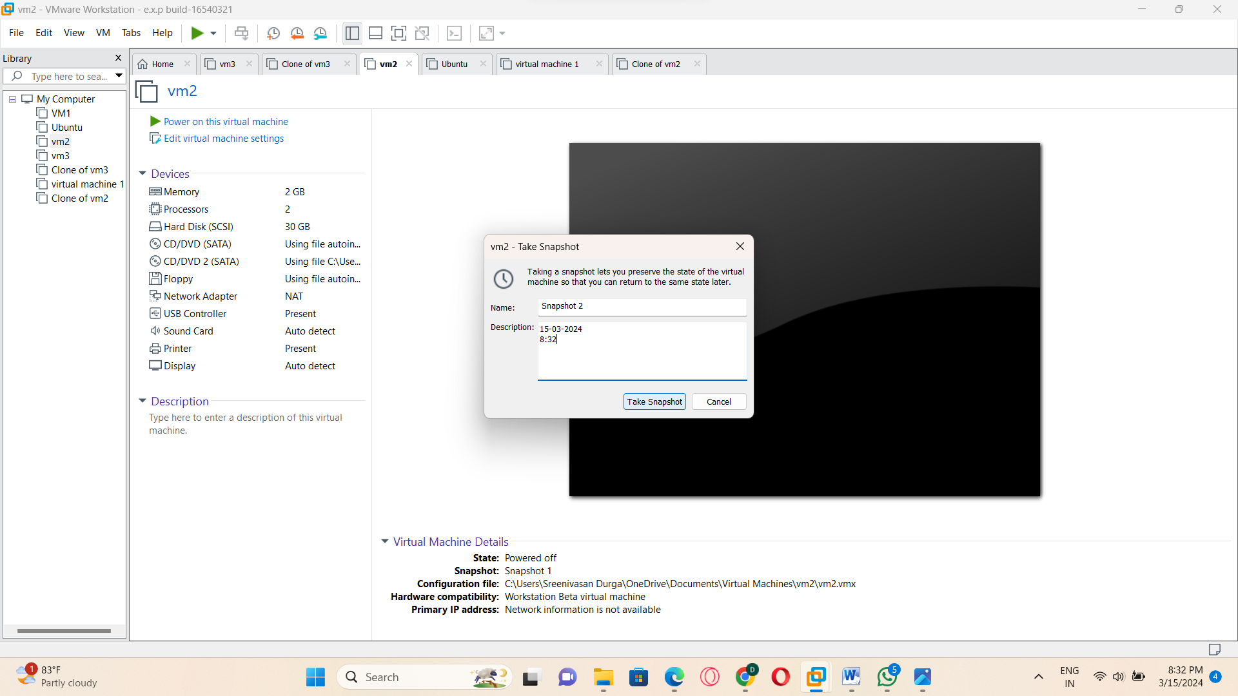

STEP:2: SAME PROCESS IS TO BE CONTINUED FOR THE SNAPSHOT:3.

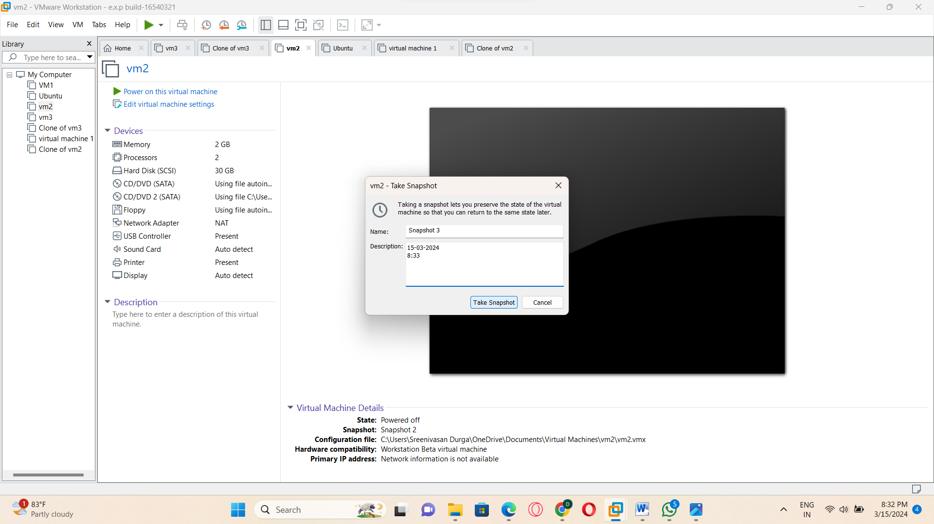

STEP:3: SNAP SHOT I1 2 AND 3 HAS BEEN DONE SUCCESSFULLY.

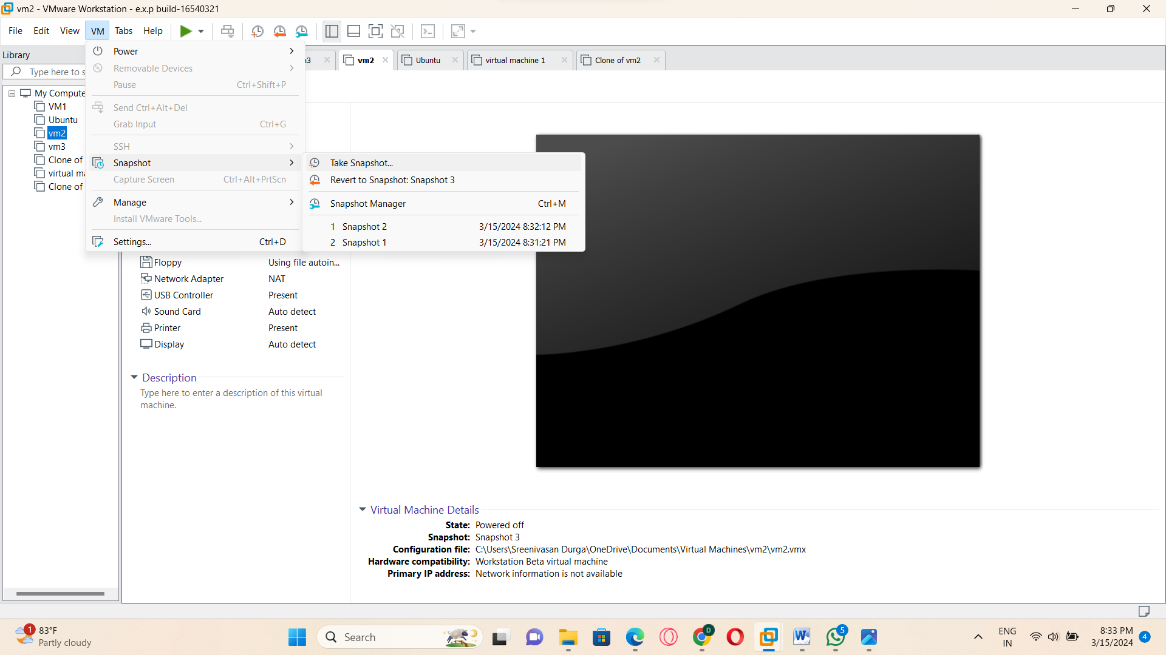

STEP:4: AND THEN AT LAST GO TO THE SNAP SHOT MANAGER.

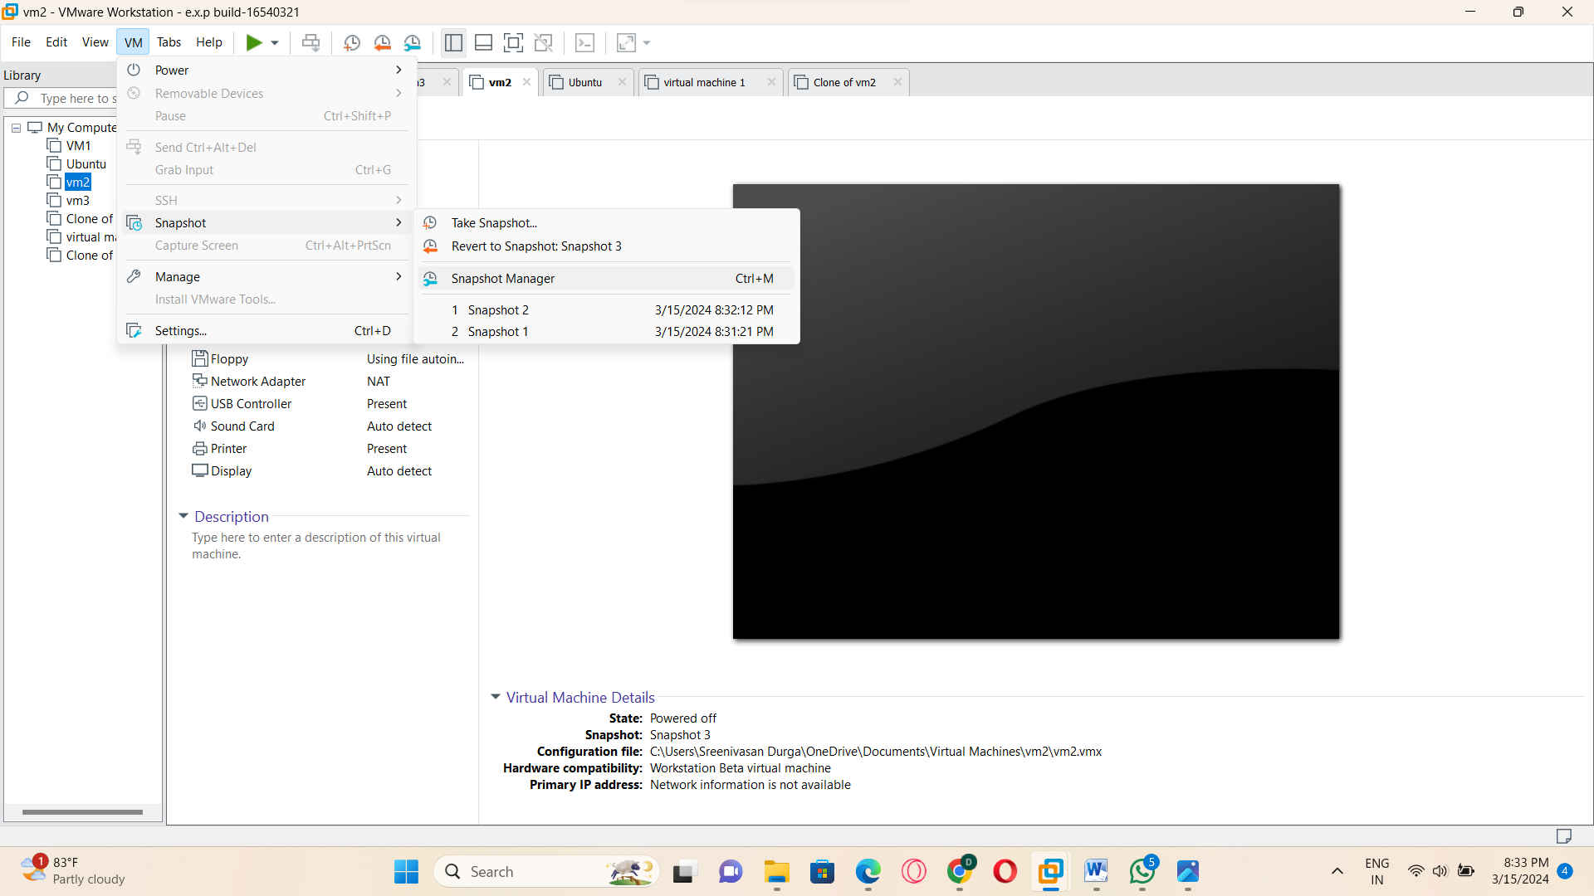

STEP:5; AND THEN SNAP SHOT FOUR:

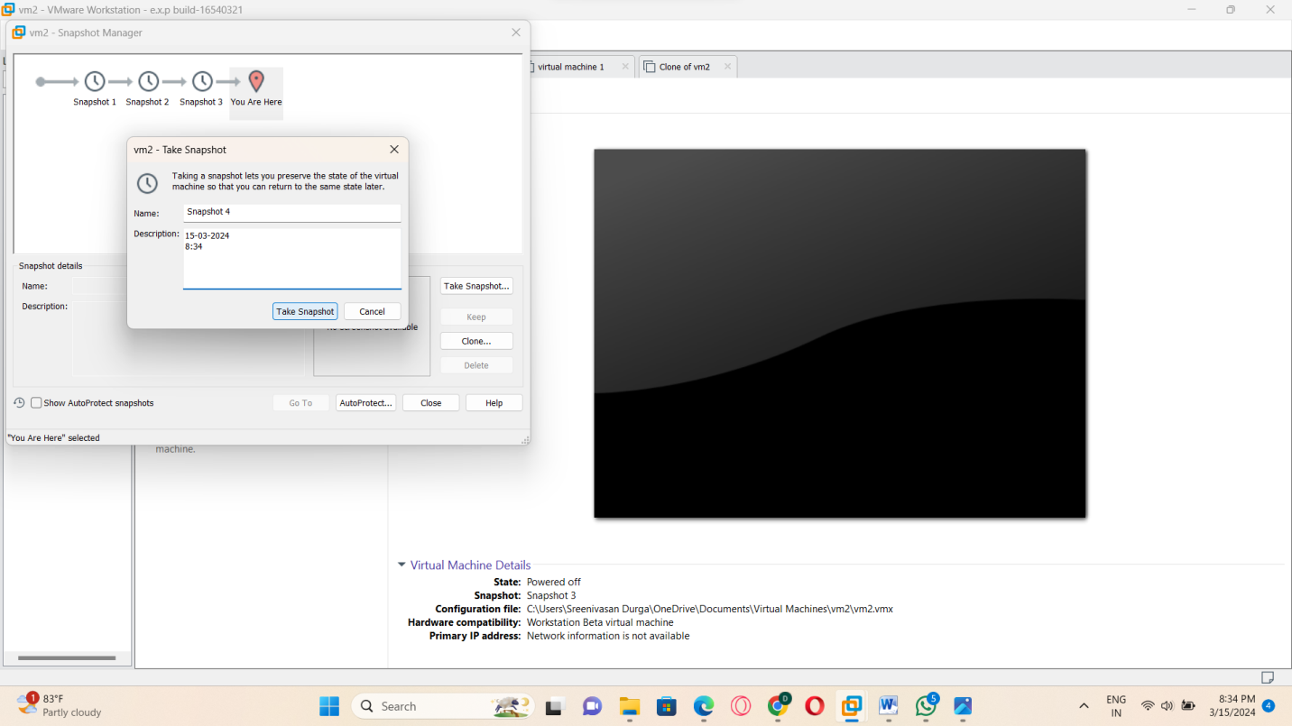

STEP:6: AND THE GO FOR THE GO TO THE PROGRAM HAS BEEN EXCEUTED SUCCESSFULLY.

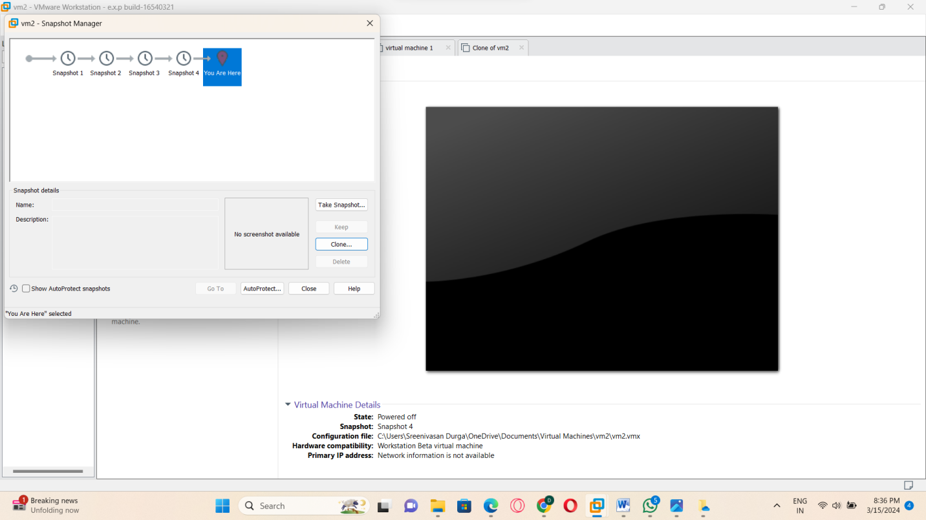

RESULT: THUS, THE PROGRAM FOR THE SNAP SHOT IN THE VM-WARE HAS BEEN EXCEUTED SUCCESSFULLY.